Course Five

The Nuts and Bolts of Machine Learning


Instructions
Use this PACE strategy document to record decisions and reflections as you work through the end-of-course project. As a reminder, this document is a resource that you can reference in the future and a guide to help consider responses and reflections posed at various points throughout projects.

Course Project Recap
Regardless of which track you have chosen to complete, your goals for this project are:
- Complete the questions in the Course 5 PACE strategy document
- Answer the questions in the Jupyter notebook project file
- Build a machine learning model
- Create an executive summary for team members and other stakeholders

Relevant Interview Questions
Completing the end-of-course project will empower you to respond to the following interview topics:
- What kinds of business problems would be best addressed by supervised learning models?
- What requirements are needed to create effective supervised learning models?
- What does machine learning mean to you?
- How would you explain what machine learning algorithms do to a teammate who is new to the concept?
- How does gradient boosting work?

Reference Guide:
This project has seven tasks; the visual below identifies how the stages of PACE are incorporated across those tasks.
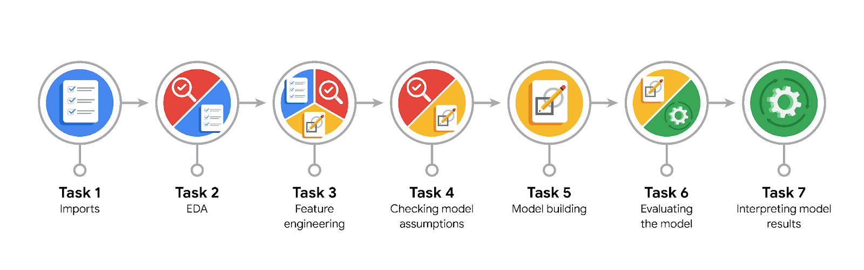

Data Project Questions & Considerations
PACE: Plan Stage
- What are you trying to solve or accomplish?
I will build a claims classification model with the random forest method, then deliver the results in an executive summary to Rosie Mae and Jaffey.

- Who are your external stakeholders that you will be presenting for this project?
Other departments in TikTok including the Project Management Team and the Operations Team

- What resources do you find yourself using as you complete this stage?
I used pd.read_csv to read the provided dataset and imported packages for data manipulation, data visualization, data preprocessing, modeling, and evaluation.

- Do you have any ethical considerations at this stage?
I believe that there could be adverse implications if the model incorrectly predicts a video’s claim status. For instance, a false negative can affect engagement metrics of a video, while a false positive can spread misinformation.
- Is my data reliable?
Yes, since I have been using this dataset in the previous stages of the project.

- What data do I need/would like to see in a perfect world to answer this question?
Being able to analyze the transcription text or the author’s talk in videos would be more helpful in determining claims vs opinions.

- What data do I have/can I get?
  - I have data on video duration, transcription text, author’s verified and ban status and 5 video engagement metrics.
  - I can extract the ratios of these engagement metrics or length of the transcription texts

- What metric should I use to evaluate success of my business/organizational objective? Why?
I use the 4 standard metrics to evaluate the model's success: accuracy, precision, recall, and f1 score since the precision and recall scores reflect the ratio of false positives and false negative to true positive, accuracy represents the percentage of records the model correctly predicted, and the f1 provides a balanced metric between the precision and recall scores.

PACE: Analyze Stage
- Revisit “What am I trying to solve?”Does it still work? Does the plan need revising?
Yes, the plan still works. After cleaning data and handling outliers, the data still maintains a class balance for claim status.

- Does the data break the assumptions of the model? Is that ok, or unacceptable?
The data should represent independent videos, while the outliers are already dealt with. For the condition of no multicollinearity between numeric variables, because the engagement metrics exhibit a relatively high correlation, particularly for the like_count variable, it would be justifiable to remove the like_count so the tree splits can be more direct.

- Why did you select the X variables you did?
I captured the ‘video_transcription_text’ variable with ‘transcription_length’ for random forest, ‘#’ and ‘video_id’ is removed because of its irrelevance, ‘video_like_count’ for the above reasons, while other variables are important in predicting claim status

- What are some purposes of EDA before constructing a model?
The EDA helps to verify important conditions for constructing a model and also perform data cleaning and structuring.

- What has the EDA told you?
The EDA validated that there are relatively equal numbers of videos about claims and opinions, it also performed data cleaning and reassigning outliers.

- What resources do you find yourself using as you complete this stage?
Pandas functions including describe, dropna(), drop_duplicates, and value_counts()

PACE: Construct Stage
- Do I notice anything odd? Is it a problem? Can it be fixed? If so, how?
The video_transcription_text is inconvenient for Random Forest, which can be fixed by extracting its length into a new column transcription_length

- Which independent variables did you choose for the model, and why?
Encoded variables of author_ban_status and verified_status have established correlation with claim_status, video engagement metrics are important since there is a difference in these metrics between claim and opinion videos & transcription_length to capture the video_transcription_text, which often suggests the claim status as well.

- How well does your model fit the data? What is my model’s validation score?
The random forest model fit incredibly well into the train dataset with 0.9949 recall score and 0.9899 in precision score. In the validation dataset it also received 0.99 scores in all 4 metrics accuracy, precision, recall, and f1. It also performed incredibly well in the test data set as well. The model only made some false positives, predicting opinions as claims, in both the validation and test dataset.

- Can you improve it? Is there anything you would change about the model?
It can hardly be improved, although another model such as CountVectorizer in analyzing the video transcription text can perform even better.

- What resources do you find yourself using as you complete this stage?
I created an XGBoost and a RandomForest classifier, then used GridSearchCV to train the model on the training set based on all possible values of certain parameters, then used .best_params_ and .best_score_ to determine the model’s parameters and recall score.

PACE: Execute Stage
- What key insights emerged from your model(s)? Can you explain my model?
The random forest model’s most important parameters are the engagement metrics, while other variables played a miniscule role in classifying claims vs opinions.
The random model used 50 estimators running up to depth 10, with each using half the samples and features, to make predictions on claim status by taking the majority vote of these estimators combined with Bagging.

- What are the criteria for model selection?
When I checked the confusion matrix, I noticed both models have 0 false negatives and 1855 true positives, while the random forest and XGBoost models predicted 23 and 26 false positives (predicting opinions as claims), so I just chose the random forest.

- Does my model make sense? Are my final results acceptable?
Yes to both questions.

- Do you think your model could be improved? Why or why not? How?
It can hardly be improved, although another model such as CountVectorizer in analyzing the video transcription text can perform even better.

- Were there any features that were not important at all? What if you take them out?
Features other than the engagement metrics were relatively unimportant, when I took them out the random forest model actually made the same number of false positives for both the validation and test set, with the video_view_count still being the most important metric out of the 4.

- What business/organizational recommendations do you propose based on the models built?
Other TikTok departments can use this model to classify future claims and opinions, although the model’s chance of classifying opinions as claims should be made transparent. Moreover, the video engagement data should be carefully monitored to prevent fluctuations that can influence the model’s accuracy in the future.

- Given what you know about the data and the models you were using, what other questions could you address for the team?
Investigate the 17 videos about opinions that were classified as claims, or collect more data about user engagement to improve the model’s metric (if necessary).

- What resources do you find yourself using as you complete this stage?
I used .best_estimator_ to run both models for the validation and test dataset, the confusion_matrix and ConfusionMatrixDisplay to show the model’s success, then generated reports with classification_report, and used .feature_importances_ to analyze the coefficients in the random forest model.

- Is my model ethical?
The model is sufficiently ethical and verified_status and author_ban_status did not play much of a role in the model’s prediction.

- When my model makes a mistake, what is happening? How does that translate to my use case?
A false positive can make more people believe that a video is telling about a fact, rather than an unverified statement (opinion), creating social and psychological consequences in the real-world.

